Project Development Phase
Performance Test

Date | 30 September 2026
Team ID | SWTID-2026-3708
Project Name | Streamlining IT Procurement: Automating Standard Laptop Orders with Flow Designer
Maximum Marks
Team Size | 4
Team Leader | A Yashmin
Team Members | Rishwana Parveen S, Deepika Sri M, Pooja S
Submitted by | A Yashmin (Team Leader)

Model Performance Testing:
Project team shall fill the following information in model performance testing template.
S.No. | Parameter | Screenshot / Values
1. | Data Rendered | Records rendered from the ServiceNow Service Catalog tables: Request REQ0010001, Requested Item RITM0010001 and Catalog Task SCTASK0010001 (Assignment group: Hardware).  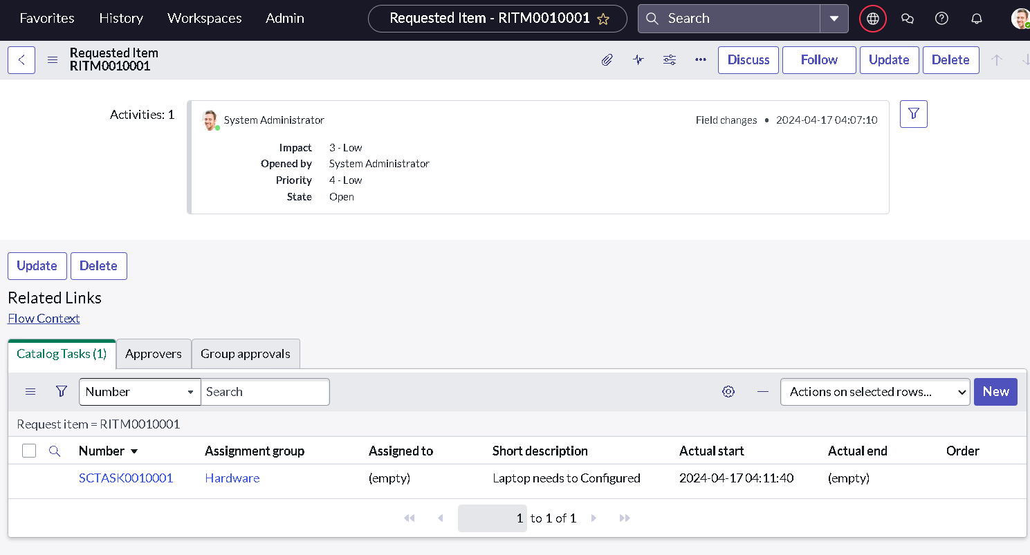  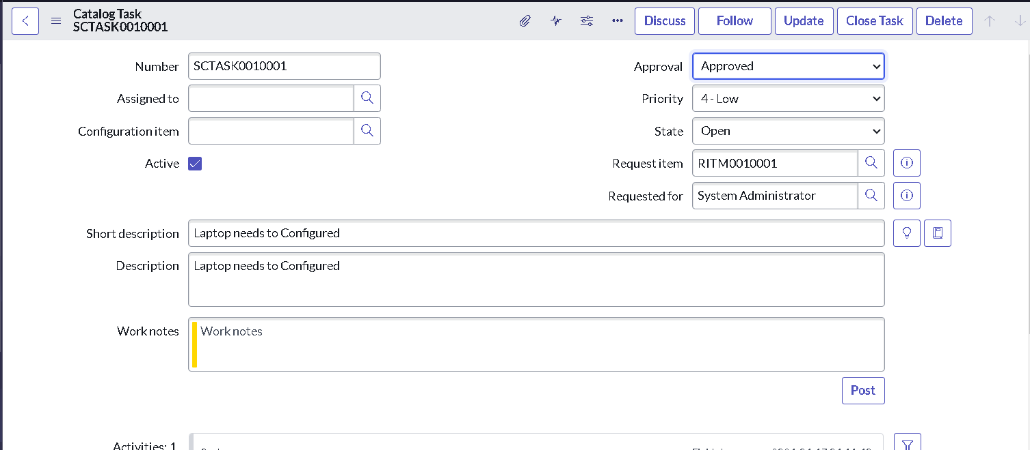
2. | Data Preprocessing | Not applicable - no Tableau data preparation. The flow writes clean values directly to the catalog task (Short description, Description, Assignment group = Hardware, Approval = Approved).  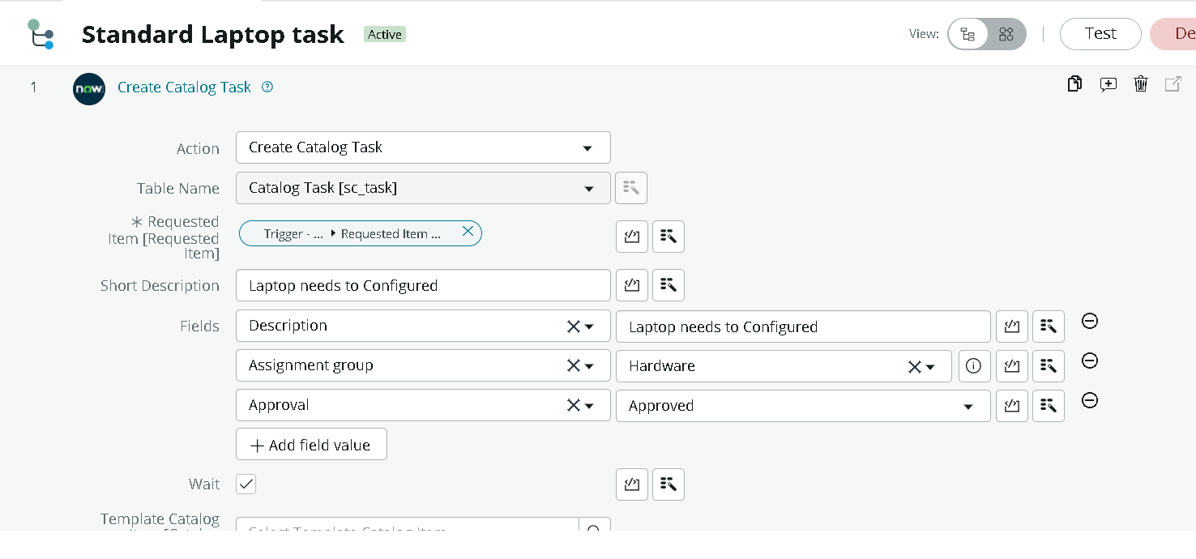
3. | Utilization of Filters | Record-list filters in ServiceNow were used to locate data: Maintain Items filtered by Name starting with "Standard" to find the Standard Laptop item, and list filters on the Approvers and Catalog Tasks tabs.  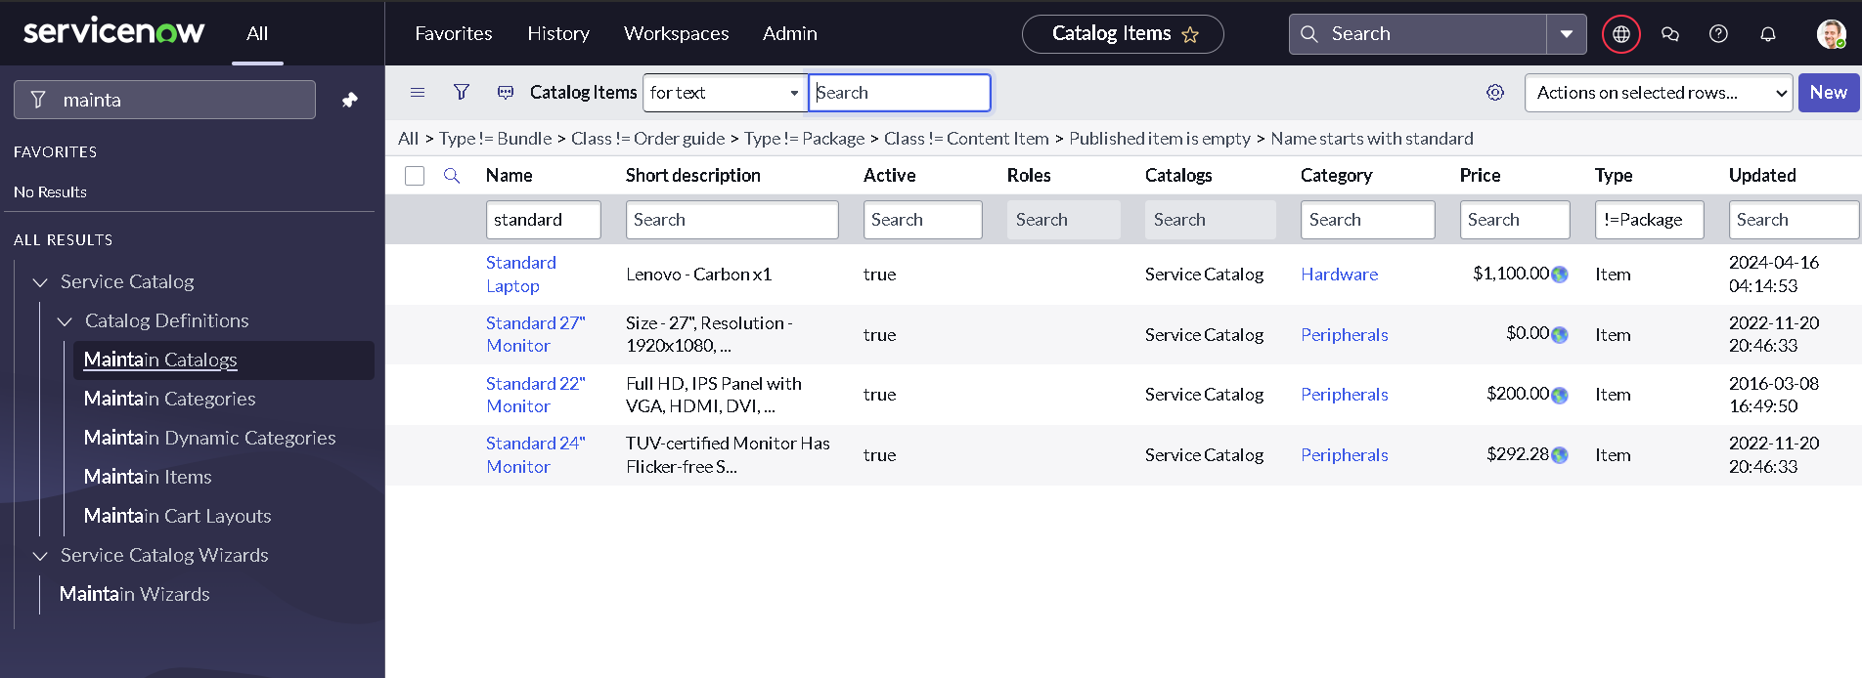
4. | Calculation fields Used | Not applicable - no calculated fields; no Tableau workbook was built for this project.
5. | Dashboard design | No of Visualizations / Graphs - 0 (the project is a ServiceNow Flow Designer automation)
6. | Story Design | No of Visualizations / Graphs - 0

